**OUTPUT OF:**

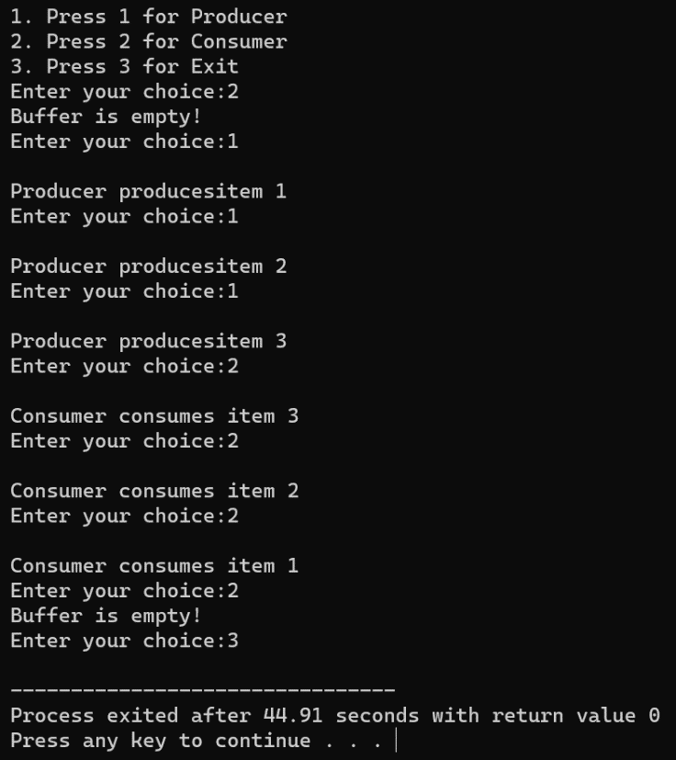**PRODUCER CONSUMER**

**DINNING-PHILOSOPHER PROBLEM**

